Richard Schall

CS-499-T4206: Computer Science Capstone

Southern New Hampshire University

April 03, 2021

* 1. **Milestone Four: Enhancement Three: Databases**

**Artifact Description**

The artifact chosen for all the enhancements and my ePortfolio is the Weather Station application. This application was developed in CS 350 – Emerging Systems and Architecture. This application was developed January through the end of February 2021.

The application has two parts there is the backend software written in Python that is ran on a Raspberry Pi 3 unit. The raspberry Pi is an embedded Linux device running the Raspbian distribution of Linux. The second part is a dashboard application that runs on the web browser of a client PC. The dashboard uses JavaScript and graphs provided by CanvasJS.

**Artifact Justification**

I chose the Weather Station application because it encompasses almost all aspects of my education at SNHU. Through enhancements, I can thoroughly demonstrate all the skills I have acquired. Specifically, in this enhancement, I am demonstrating my knowledge of databases in the Weather Station Python code and in the Raspberry Pi unit. The enhancements show my ability to install the MySQL fork server named MariaDB, create a database in the server, create a table in the database, and modify the Python application to write data to the database. I then query data back out of the database manually.

The database enhancement is in my opinion the most significant enhancement thus far. I had to install MySQL on the Raspberry Pi. Through research I found that the Raspbian supports the MariaDB SQL server. This is a forked version of MySQL.

**Install MariaDB onto the Raspberry Pi unit:**

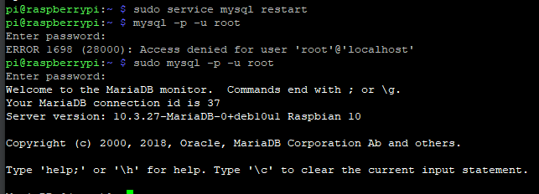

**Create a Database Named ‘WEATHER_STATION’:**

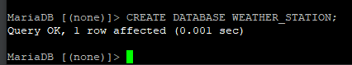

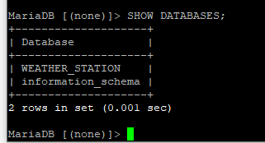

**Create a Table Name ‘temperature_humidity’:**

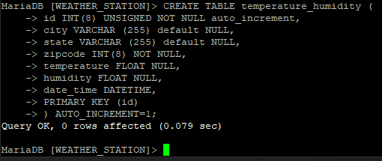

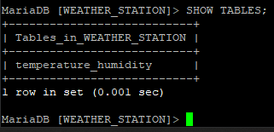

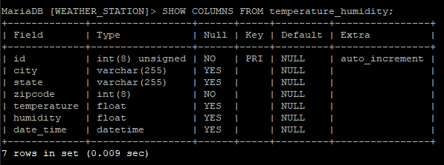

**Insert Data into the Table and Query Data Back Out:**

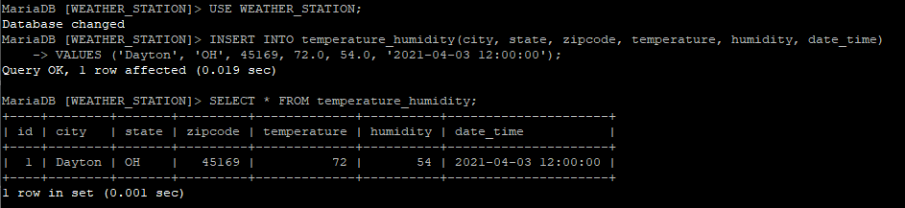

The next step was modifying the Python code to connect and write the temperature and humidity into the temperature_humidity table of the WEATHER_STATION database

**Install the Python MySQL Connector Driver:**

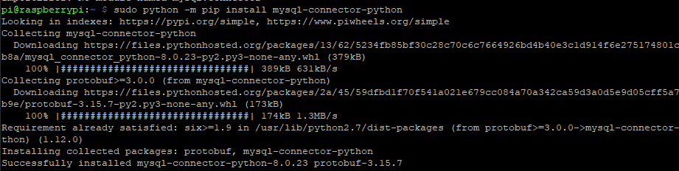

**Python Enhancement Code:**

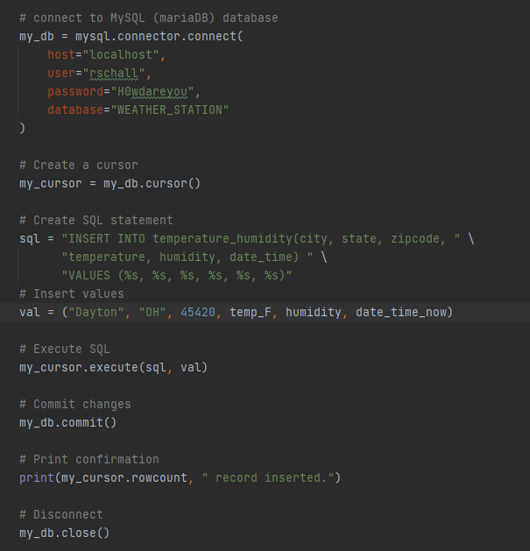

**Querying Data from the WEATHER_STATION Database:**

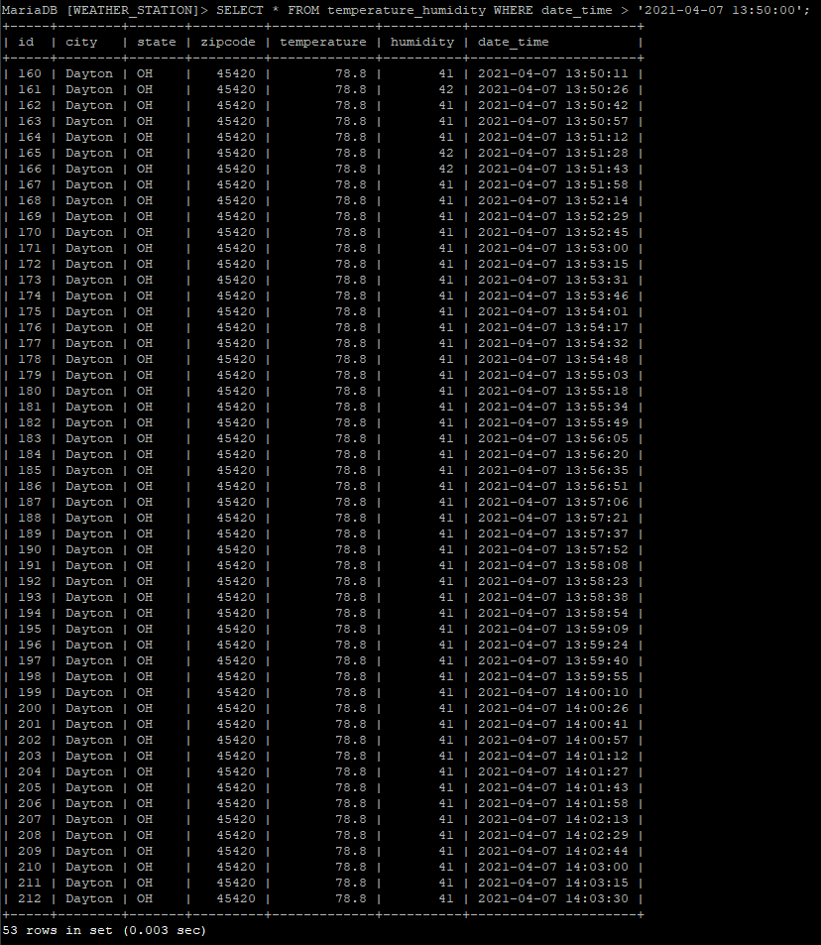

**Objectives**

I feel very good that I have met the objectives for the enhancements in Milestone Four. That database portion is the enhancement I was most nervous about and the most looking forward too. I am happy that I chose the Raspberry Pi project to do this enhancement for my ePortfolio. The Raspberry Pi is such a great learning tool.

The original project did not use a MySQL database. I had to figure out how to install the MariaDB server onto the Raspberry Pi. My first approach was to install MySQL, it turns out the most update MySQL server is a forked version of MySQL name MariaDB. This demonstrated my ability to learn and overcome a hurdle to completing the task at hand.

At the conclusion of this I have a weather station that has SQL server installed and logging temperature and humidity data. There are several paths this opens for this application. I can enhance the dashboard with all kinds of statistical data from data pulled from the database on the Raspberry Pi. This data can be shared with third parties as well.

**Reflection**

Working my way through this capstone course has been great. It is a summation of my learning; I have needed to go back and revisit notes and materials from several of my courses. It has been a good review of how I have grown.

I will need to go back through an refactor the additions to the Python code I made this week. My goal this week as to get the SQL server installed, a database created, a table set up, and writing data to the table. I have achieved all those things. The code is functional. This will not be good enough for my ePortfolio. I need to break out the SQL code into a separate component I can access from the main routine. I also have some hard coded values I need to migrate to the configuration JSON file.